Algorithms and Data structure

Exercise 2: E-commerce platform search function:

1.Code:

public class Product {  
 int productId;  
 String productName;  
 int quantity;  
 float price;  
  
 Product(int productId, String productName, int quantity, float price) {  
 this.productId = productId;  
 this.productName = productName;  
 this.quantity = quantity;  
 this.price = price;  
 }  
}

public class search{  
  
 static int linearSearch(Product[] arr, String name) {  
 int n = arr.length;  
 for (Product product : arr) {  
 if (product.productName.equals(name)) {  
 return product.productId;  
 }  
 }  
 return -1;  
 }  
  
 static int binarySearch(Product[] arr, String name) {  
 int n = arr.length;  
 int l = 0, h = n - 1;  
 while (l <= h) {  
 int m = (l + h) / 2;  
 int cmp = arr[m].productName.compareToIgnoreCase(name);  
  
 if (cmp == 0) return arr[m].productId;  
 else if (cmp < 0) l = m + 1;  
 else h = m - 1;  
 }  
 return -1;  
 }  
}

public class Test {  
 public static void main(String[] args) {  
 Product[] products = {  
 new Product(1, "Laptop", 1000,50000),  
 new Product(2, "Shoes",5200,550 ),  
 new Product(3, "Book", 5000,150),  
 new Product(4, "Smartphone", 2000,15000),  
 new Product(5, "Watch", 3000,2000)  
 };  
  
 System.*out*.println("Linear Search for 'Shoes':");  
 int id = search.*linearSearch*(products, "Shoes");  
 System.*out*.println(id!=-1 ? "Found at " +id+" place": "Product not found");  
  
 System.*out*.println("Binary Search for 'Smartphone':");  
 int bid = search.*binarySearch*(products, "Smartphone");  
 System.*out*.println(bid != -1 ? "Found at " + bid +" place": "Product not found");  
 }  
}

2.Output:

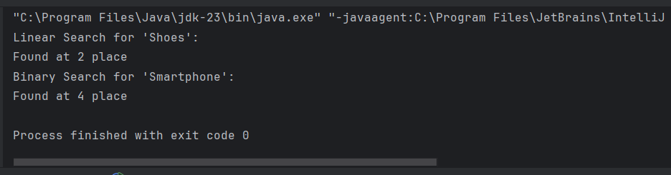

Exercise 7: Financial Forecasting:

1.Code:

public class FinancialForecast {  
 public static float futureValue(float currentValue, float rate, int time) {  
 if (time == 0) {  
 return currentValue;  
 }  
 return *futureValue*(currentValue \* (1 + rate), rate, time - 1);  
 }  
  
 public static void main(String[] args) {  
 float principle = 10000.0F;  
 float rate = 0.10F;  
 int years = 5;  
  
 float value = *futureValue*(principle, rate, years);  
 System.*out*.println("Future value: " + value);  
  
 }  
}

2.Output:

